Wednesday 10th November 2021

Analogue Sound

Sound Sampling

Samples of a sound wave are taken at regular intervals. When a sample of analogue sound is taken, a snapshot of the sound at that exact moment is saved. The greater the sample rate, the higher the quality of the resulting file. The sample interval is the time that passes between each sample. This lower the interval, the more samples are taken, meaning a higher quality recording.

A CD has a sample rate of 44,100 samples per second (44.1 kHz). A Blu-ray disk has a sample rate of 96,000 samples per seconds (96 kHz)

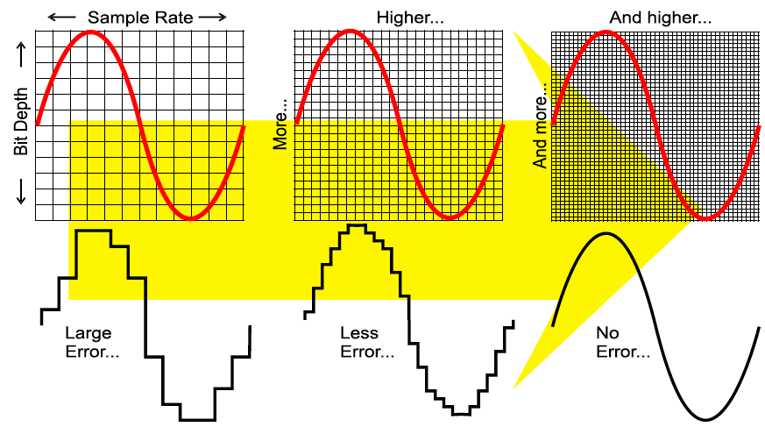

Bit Depth

The bit depth is the number of bits used to store each sample. Using 8-bits allows for 256 changes in volume, using 16 means 65,536 bits.

Amplitude and Stereo Sound

The amplitude is how much the air is moved by a sound, also known as the loudness.

A CD is recorded in Stereo. This means that there are two tracks of audio, one is left, and the other is right. Because there are two tracks, the file size of the recording is doubled.

Calculating File Size

You can calculate the size of an audio recording using:

**File Size** (bits) **= Sample Rate** x **Bit Depth** x **Recording Length** (seconds)

**A –** Sound Wave

**B –** Sample Interval

**C –** Amplitude

